FITTRACK: AI-Based Fitness Tracking and Personalized Fitness

Recommendations Project Description
FITTRACK is a secure, AI-powered fitness tracking application that helps users maintain their workout records and receive personalized fitness recommendations. The system provides RESTful APIs for user authentication, workout management, workout searching and AI-assisted fitness guidance.
The backend is developed using Node.js and Express.js, and MongoDB is used to store user and workout information through Mongoose. FITTRACK follows a modular MVC architecture and uses JWT authentication to protect user-specific operations, while passwords are handled securely using bcrypt.js. The system also integrates Google Gemini AI to generate personalized workout recommendations and fitness insights based on user information and workout statistics. Centralized error handling ensures proper validation and consistent management of application errors.

Scenarios

Scenario 1: User Registration and Login
A new user registers using the authentication API and logs in with an email and password. After successful login, the system generates a JWT token. The token is used for accessing protected APIs.

Scenario 2: Workout Management
The authenticated user adds workout details such as workout name, category, duration, calories burned and workout date. The user can then view, search, update and delete workout records.

Scenario 3: AI Fitness Recommendation
The user provides information such as age, fitness goal and experience level. FITTRACK sends this information to Google Gemini AI and returns personalized workout recommendations, weekly suggestions, motivational guidance and safety-oriented suggestions.

Scenario 4: Fitness Insights
The system uses workout statistics such as total workouts, average workout duration and calories burned to generate personalized fitness insights.

Technical Architecture

FITTRACK follows a modular MVC-based backend architecture. Clients such as a web application, mobile application, Postman or Thunder Client send requests to the Express backend. The backend routes requests through authentication middleware, controllers and services, while MongoDB stores application data and Gemini AI provides AI-generated fitness recommendations.

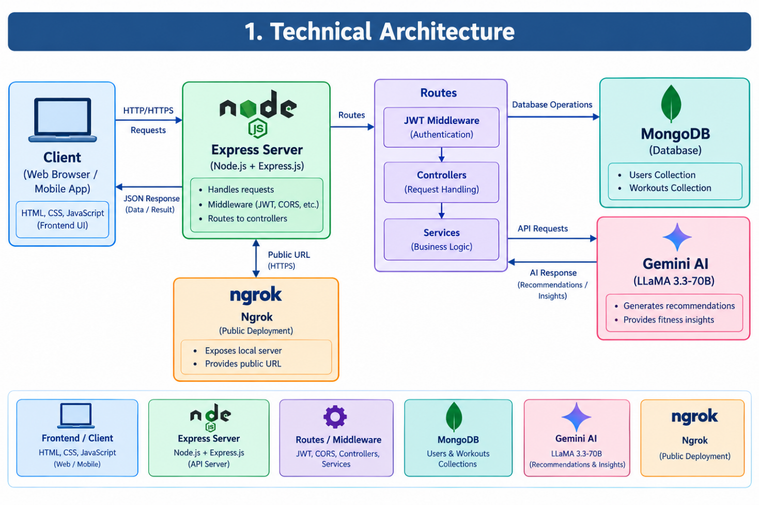

Architecture Flow: Client → Express Server → Routes → Authentication Middleware → Controllers → Services / Mongoose → Gemini AI / MongoDB Architecture Components

Component | Description
Client Layer | Sends requests to the FITTRACK backend and receives JSON responses.
Express Server | Receives API requests and manages communication between routes, controllers, services and database.
Route Layer | Defines authentication, workout and AI API endpoints.
Authentication Middleware | Verifies the JWT token before allowing access to protected APIs.
Controller Layer | Processes incoming requests and generates responses.
Component | Description
Service Layer | Contains reusable application services such as Gemini AI, JWT and password services.
Database Layer | MongoDB stores application information; Mongoose provides schemas, validation and database operations.

MVC Architecture

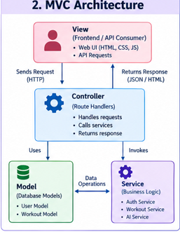

Layer | Description
Model | Manages database information using MongoDB, Mongoose, User model and Workout model.
View | Represents the client consuming the API, such as web/mobile applications, Postman or Thunder Client.
Controller | Receives requests, validates input, executes application logic and communicates with models and services.

Database Design

FITTRACK contains two major entities: User and Workout.

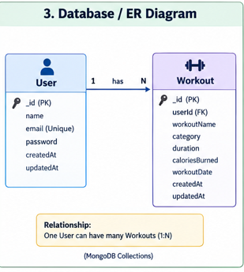

User Field | Description
_id | Unique user ID
name | User name
email | User email
password | Encrypted password
createdAt | Creation time
updatedAt | Update time
Workout Field | Description
_id | Unique workout ID
user | User reference
workoutName | Workout name
category | Workout category
duration | Workout duration
caloriesBurned | Calories burned
workoutDate | Workout date
createdAt | Creation time
updatedAt | Update time

Pre-requisites
- Node.js and Express.js knowledge.
- MongoDB and Mongoose knowledge.
- JWT authentication knowledge.
- Google Gemini AI familiarity.
- JavaScript proficiency.
- API testing using Postman or Thunder Client.
- Visual Studio Code and npm basics.

Project Workflow

Milestone 1: Project Setup and Architecture
- Initialize the FITTRACK project using npm.
- Set up Node.js and Express.js.
- Define the modular MVC architecture.
- Configure MongoDB and Mongoose.
- Configure environment variables for PORT, MONGO_URI, JWT_SECRET and GEMINI_API_KEY.

Milestone 2: Authentication and User Management
- Implement user registration and login.
- Hash passwords securely using bcrypt.js.
- Generate and verify JWT tokens.
- Protect restricted API routes using authentication middleware.

Milestone 3: Workout Management
- Create workout records.
- Retrieve all workouts and individual workouts.
- Search workouts by workout name, category and date.
- Update workout details.
- Delete workout records.

Milestone 4: AI Features Development
- Integrate Google Gemini AI.
- Accept age, fitness goal and experience level as inputs.
- Generate personalized workout recommendations.
- Generate weekly workout suggestions and motivational/safety guidance.
- Generate fitness insights from workout statistics.

Milestone 5: API Testing
- Test authentication APIs using Postman or Thunder Client.
- Test workout CRUD APIs.
- Test workout search and individual workout APIs.
- Test protected routes using JWT authentication.

Milestone 6: Project Execution and Outcome
- Start the backend server using the configured npm command.
- Verify API operations using Postman or Thunder Client.
- Confirm centralized error handling and database operations.
- Demonstrate the completed FITTRACK backend.

Milestone 1: Project Setup and Architecture
This milestone establishes the FITTRACK backend foundation and defines how the client, Express server, authentication middleware, controllers, services, MongoDB and Gemini AI communicate.

Activity 1.1: Initialize the Project
The project folder is named AI-FitTrack-API. Initialize the project using: npm init -y

Activity 1.2: Install Required Packages
The FITTRACK backend uses Express, Mongoose, dotenv, bcryptjs, jsonwebtoken and cors. Nodemon is used as a development dependency.
npm install express mongoose dotenv bcryptjs jsonwebtoken cors npm install --save-dev nodemon

Activity 1.3: Configure Environment Variables
Variable | Purpose
PORT | Server configuration
MONGO_URI | Database connection
JWT_SECRET | Authentication
GEMINI_API_KEY | Gemini AI integration

Activity 1.4: Define Application Architecture

Client → Express Server → Routes → Authentication Middleware → Controllers → Services / Mongoose → Gemini AI /
MongoDB

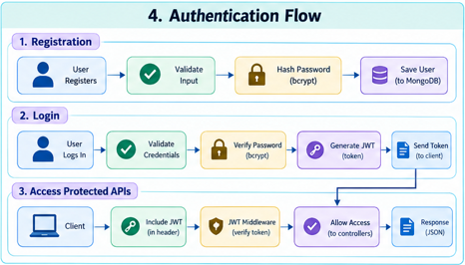

Milestone 2: Authentication and User Management
Activity 2.1: User Registration
The user registers with the required account information. The password is protected using bcrypt.js before it is stored.
Activity 2.2: User Login
The system verifies the user's email and password and generates a JWT token for authenticated API access.

Activity 2.3: Authentication Middleware
The middleware verifies the JWT token before allowing requests to protected APIs. If the token is missing or invalid, the protected request is rejected.

Milestone 3: Workout Management

Activity 3.1: Workout CRUD Operations
Authenticated users can add, view, update and delete workout records. Each record contains workout name, category, duration, calories burned and workout date.
Activity 3.2: Workout Search
Workout records can be searched using workout name, category and date.

Milestone 4: AI Features Development
Activity 4.1: Google Gemini Integration
FITTRACK uses Google Gemini AI to provide personalized fitness guidance.

Activity 4.2: Personalized Recommendations
The user can provide age, fitness goal and experience level. Gemini AI generates personalized workout recommendations, weekly workout suggestions, experience-level recommendations, motivational guidance and safety-oriented suggestions.

Activity 4.3: Fitness Insights
FITTRACK uses total workouts, average workout duration and calories burned to generate personalized fitness insights. AI Flow: User Information → Age + Fitness Goal + Experience → Gemini AI → Personalized Recommendation

Milestone 5: API Testing

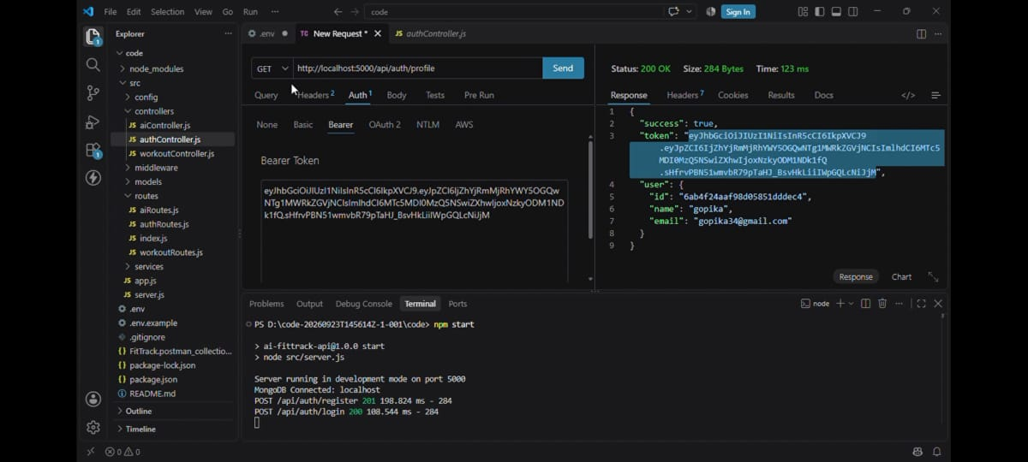

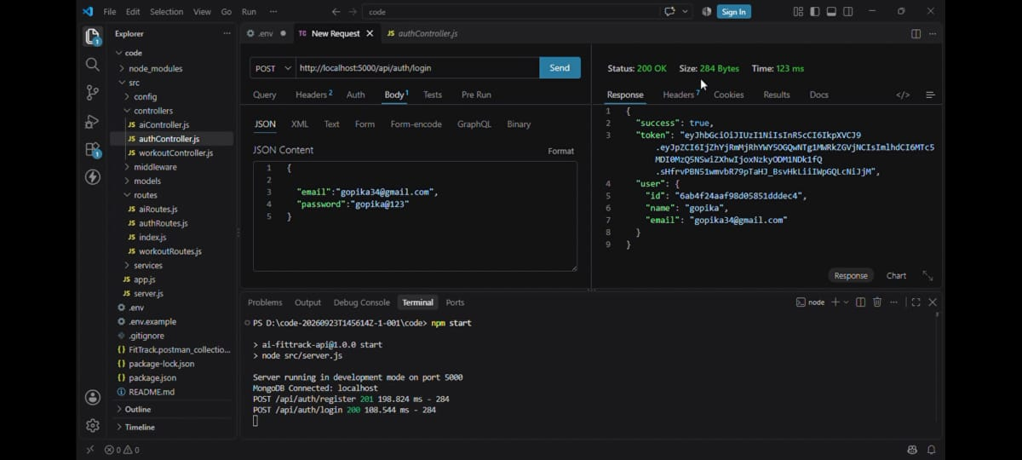
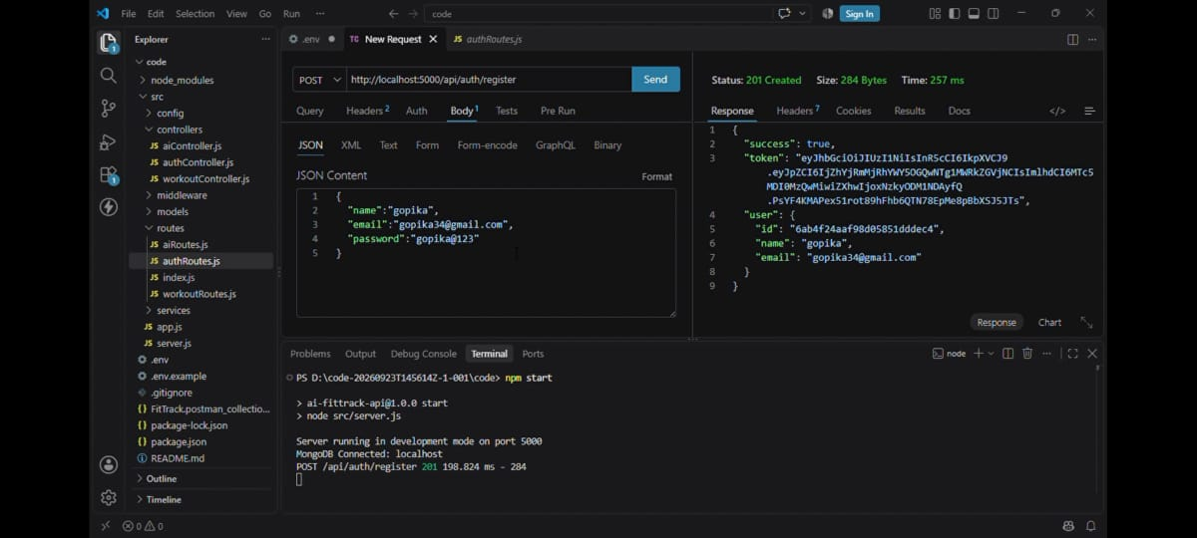

Activity 5.1: Authentication API Testing

Category | APIs
Authentication APIs | Register User, Login User, Get Profile

Activity 5.2: Workout API Testing

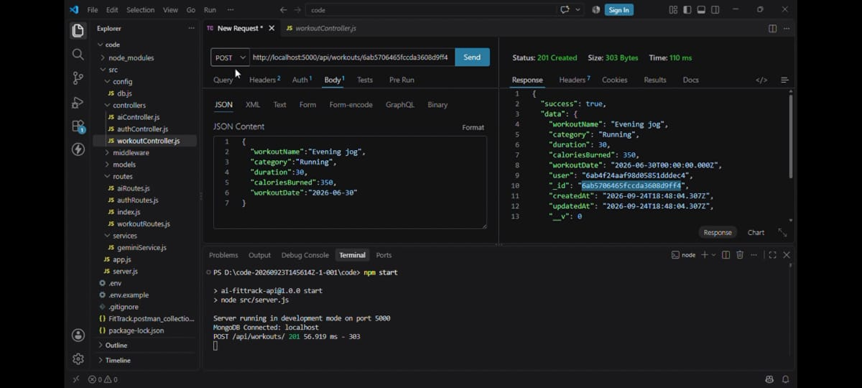
Category | APIs
Workout APIs | Add Workout, Get All Workouts, Search Workout, Get Workout By ID, Update  Workout, Delete Workout
The APIs can be tested using Postman or Thunder Client. Protected endpoints require JWT authentication.

Key Features
- Secure Authentication — registration, login, JWT protection and bcrypt.js password handling.
- Workout Management — add, view, update and delete workout records.
- Workout Search — search by workout name, category and date.
- Google Gemini Integration — personalized workout recommendations.
- AI Fitness Insights — insights based on workout statistics.
- Centralized Error Handling — centralized validation and error management.
- RESTful API — structured JSON responses following REST principles.
- Modular Architecture — routes, controllers, services, models, middleware and configuration are separated.

User Roles and Authentication
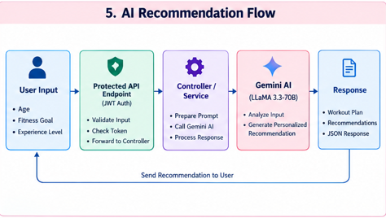

The primary role in FITTRACK is the authenticated user.

Function | Permission
Register | Allowed
Login | Allowed
View Profile | Allowed
Add Workout | Allowed
View Workout | Allowed
Search Workout | Allowed
Update Workout | Allowed
Delete Workout | Allowed
AI Recommendation | Allowed
Function | Permission
Fitness Insights | Allowed

Authentication Process: Register → Login → JWT Generated → JWT Sent With Request → Middleware Verification → Protected API Access

System Usage
- Register using an email and password.
- Log in and receive a JWT token.
- Add a workout.
- View all workouts.
- Search workouts.
- View a particular workout.
- Update workout details.
- Delete workouts.
- Request AI recommendations.
- Generate fitness insights.

Outcome
FITTRACK provides a centralized solution for managing fitness and workout information. The system reduces the need for manual workout record management and provides an organized method for storing and retrieving fitness data.
- Secure user authentication.
- Centralized workout management.
- Easy workout searching.
- Personalized AI recommendations.
- Fitness performance insights.
- Structured REST APIs.
- Modular backend architecture.
- Secure database access.

Conclusion
The project demonstrates how a secure RESTful backend can combine structured fitness tracking with AI-powered assistance. The modular design provides a foundation for future interface development and additional fitness-related capabilities.

